A
PROJECT-IV REPORT
On
InfraVision
A Next-Gen Infrastructure optimization Platform
Submitted by:
Kislay Kumar (230555)
Asad Ahmad (230)
under mentorship of
Dr. Shilpa Mahajan
Assistant Professor

Department of Computer Science Engineering
School of Engineering and Technology
BML MUNJAL UNIVERSITY, GURUGRAM (INDIA)
May 2024

CANDIDATE’S DECLARATION

I hereby certify that the work on the project entitled, ”Financial Modelling Software”, in partial fulfillment of requirements for the award of Degree of Bachelor of Technology in School of Engineering and Technology at BML Munjal University, having University Roll No.1232434, is an authentic record of my own work carried out during a period from January 2026 to May 2026 under the supervision of Dr. Shilpa Mahajan.

Kislay Kumar
Asad Ahmad

SUPERVISOR’S DECLARATION

This is to certify that the above statement made by the candidate is correct to the best of my knowledge.

Faculty Supervisor Name: Dr. Shilpa Mahajan
Signature

ACKNOWLEDGEMENT

I am highly grateful to DR. SHILPA MAHAJAN, ASSISTANT PROFESSOR, BML Munjal University, Gurugram, for providing supervision to carry out the seminar/case study from January-May 2026.
Dr. Shilpa Mahajan has provided great help in carrying out my work and is acknowledged with reverential thanks. Without wise counsel and able guidance, it would have been impossible to complete the training in this manner.
I would like to express thanks profusely to thank Dr. Shilpa Mahajan, for stimulating me from time to time. I would also like to thank the entire team at BML Munjal University. I would also thank my friends who devoted their valuable time and helped me in all possible ways toward successful completion.

Kislay Kumar
Asad Ahmad

TABLE OF CONTENT

 | Content | Page No.
 | List of Figures | 5
 | List of Table | 6
 | List of Abbrevation | 7
 | Abstract | 8
1 | Introduction | 9
2 | Introduction To The Project | 10
2.1 | Overview | 10
2.2 | Existing System | 10
2.3 | User Requirement Analysis | 11
2.4 | Feasibility Study | 12
3 | Literature Review | 13
3.1 | Comparison of Existing Research Work | 14
3.2 | Objectives of the Project | 14
4 | Methodology | 16
4.1 | Introduction to Technologies | 16
4.2 | Supporting APIs, Libraries and Packages | 16
4.3 | User Characteristics | 17
4.4 | Constraints | 18
4.5 | System Flow and Data Flow | 19
4.6 | Database Design | 20
4.7 | Data Structure | 20
4.8 | ER Overview | 21
4.9 | Assumption and Dependencies | 22
4.10 | Algorithm Design | 22
4.11 | Conclusion | 22
5 | Results | 23
5.1 | System Interface and Initial Configuration | 23
5.2 | Intrinsic Valuation and Decision Matrix | 24
5.3 | LBO Analysis | 25
5.4 | Stochastic Risk and Monte Carlo Distribution | 26
5.5 | Financial Archeology | 27
5.6 | Synthesis and Executive Commentary | 28
5.7 | Conclusion | 29
6 | Conclusion and Future Scope | 30
6.1 | Conclusion | 30
6.2 | Future Scope | 30
7 | Bibliography | 31

LIST OF FIGURES

Figure No. | Figure Description | Page No.
1 | Workflow of the Financial Modelling System | 19
2 | System Data Flow Process | 20
3 | ER Diagram of the System | 21
4 | Landing Page Interface | 23
5 | Intrinsic Valuation and Decision Matrix | 24
6 | LBO Analysis | 25
7 | Monte Carlo Distribution | 26
8 | LBO Return Distribution | 26
9 | Financial Archeology | 27
10 | Executive Summary | 28

LIST OF TABLE

Table No. | Table description | Page No.
1 | Comparing of Existing Work | 14
2 | Technology Stack and System Components | 16
3 | Supporting Libraries, APIs and Tools used in the system | 16
4 | Constraints in the system | 18
5 | Virtual Table Structure used in the System | 20

LIST OF ABBREVIATION

Acronym | Terminology
AAPL | Apple
WACC | Weighted Average Cost of Capital
DCF | Discounted Cash Flow
FDSS | Financial Decision Support System
DSS | Decision Support System
LBO | Leveraged Buyout
LBA | Linear Ballistic Accumulator
API | Application Programming Interface
CSS | Cascading Style Sheets
CCA | Comparable Company Analysis
FMP | Financial Modelling Prep
yfinance | Yahoo Finance
EBITDA | Earning Before Taxes, Interest, Depreciation and Amortization
IRR | Internal Rate of Return
VAR | Value at Risk
MOIC | Multiple of Invested Capital

ABSTRACT

This project focuses on building InfraVision, a comprehensive Next-Gen Infrastructure Optimization Platform that goes beyond the limitations of traditional, static urban planning methods. By integrating diverse modules including road and housing planning, urban growth prediction, and multi-dimensional sustainability analytics into a single interactive Next.js 14 dashboard, the system offers a more dynamic and practical way to optimize city-wide resource allocation and infrastructure development. Instead of relying only on historical assumptions, the system incorporates advanced machine learning forecasting using XGBoost, Prophet, and Random Forest models. This allows it to capture urban evolution patterns and account for resource volatility that is often overlooked in standard models. To ensure algorithm transparency, the project utilizes SHAP (Shapley Additive Explanations), opening the "black box" of AI to reveal exactly which variables from population density to environmental constraints are driving localized infrastructure scores. One of the more distinctive aspects of the project is the integration of a Digital Twin simulation engine. This approach allows for real-time "stress testing" of new infrastructure projects, such as a proposed road network or housing development, within a virtual environment. It adds an extra layer of predictive analysis that connects digital twins with real-world Linear Programming (LP) optimization, modelling how city systems will actually respond to new physical constructions under varying demographic pressures. To make the system more user-friendly, an AI Insights Layer has been included that converts complex numerical telemetry and ML outputs into clear, concise summaries. This helps in presenting key takeaways and "Digital Node" deployment strategies in a format that is easier to understand, especially for administrators requiring rapid, informed decision-making in complex urban environments. Overall, the goal of this project was to create an infrastructure optimization tool that feels more responsive and intuitive, while remaining technically robust and aligned with the future of smart city management.
.

- INTRODUCTION

In the world of modern urban management, accurately optimizing city infrastructure has always been a challenging and evolving task. While traditional methods like static master plans and periodic surveys have served as the standard for decades, they are often limited by their rigidity. Even today, many urban planners rely on isolated datasets and static spreadsheets that require tedious manual updates and struggle to keep pace with the rapid volatility of urban growth and resource consumption. This project, InfraVision, was developed to address these limitations by combining established urban planning principles with a flexible, computation-driven framework capable of adapting to real-time city dynamics. The primary objective of this system is to bridge the gap between intuition-based planning and structured, data-driven optimization. Instead of generating a single, fixed plan, the system is designed to present a range of possible growth trajectories and optimization scenarios, offering a more comprehensive and realistic view of city development under uncertainty. To achieve this, multiple layers of analysis have been integrated, starting with core sustainability metrics for water, energy, and waste, and extending to advanced predictive methods such as Smart Road and Housing Planning. These models analyse historical patterns to predict future infrastructure needs, helping administrators assess growth patterns and mitigate resource scarcity more effectively.
Beyond purely numerical analysis, the system also incorporates an Explainable AI (XAI) core, adapted from game theory. This component decomposes the complexity of machine learning models by identifying the individual impact of variables on the final optimization score. As a result, the system not only provides predictive outputs but also offers a transparency layer, reflecting how complex infrastructure decisions are actually influenced by underlying data points.
From a technical standpoint, the platform is built using a high-performance Next.js 14 frontend and a robust Python FastAPI AI backend. This enables the creation of an interactive dashboard that remains intuitive while handling intensive AI computations. The system’s architecture is powered by a fusion of Municipal Corporation of Delhi (MCD) datasets and GeoJSON spatial boundaries, ensuring localized accuracy. Additionally, the system supports Digital Twin technology, allowing for the "stress testing" of policies in a virtual environment before they are deployed. This dual-stack approach ensures both speed and analytical depth.
This report provides a detailed overview of the system’s architecture and functionality. It explores the mathematical foundations of the predictive models, the implementation of resource optimization algorithms, and the methods used to transform complex urban telemetry into actionable insights. Overall, the project aims to make advanced infrastructure optimization more accessible while enabling more informed and confident decision-making based on comprehensive, real-time data analysis.

- INTRODUCTION TO THE PROJECT

2.1 Overview
The proposed system, InfraVision - Next Gen Infrastructure Optimization, is an urban analytics software developed to automate, standardize, and enhance the process of city planning and resource allocation. Traditional urban planning approaches often operate in silos where road network models are built separately from energy or water management systems and risk analysis is either minimal or performed using simplified, static assumptions. This project addresses that fragmentation by integrating multiple infrastructure methodologies into a single, cohesive intelligence platform. At its core, the system combines Infrastructure Analytics (for roads and housing), Predictive Machine Learning (for urban growth patterns), and Sustainability Intelligence to capture the full complexity of the urban environment. These components are not just implemented independently but are interconnected, allowing users to analyse how changes in one sector such as a new housing development affect the entire city's sustainability landscape, from water demand to traffic flow.
The system is designed to be dynamic rather than static. By incorporating real-time data through a centralized AI backend and embedding simulation-based approaches, it transforms city planning from a periodic, one-time calculation into an interactive analytical process. Users can explore multiple "Digital Node" deployment scenarios, test infrastructure assumptions, and observe how city health scores shift under different growth conditions. The inclusion of an Explainable AI (XAI) layer further enhances the system by linking quantitative outputs with transparent reasoning, making the results more aligned with real-world administrative decision-making and policy formulation.

2.2 Existing System
Currently, most infrastructure management and urban planning tasks are performed using fragmented, legacy systems or manual, document-based reporting tools. While these methods have provided a baseline for city administration for years, they present several structural and operational limitations when used for advanced urban analytics. A primary challenge is the reliance on manual data collection and entry, where planners are required to gather resource metrics and project details from various disparate government departments and input them manually into reports. This process is inherently time-intensive and significantly increases the likelihood of human error, data inconsistencies, and the use of outdated information for critical development decisions.
Furthermore, the existing architecture is largely static and deterministic. Traditional urban models are typically built as fixed templates or master plans that are updated only once every several years. Updating core assumptions, such as projected urban density, utility demand surges, or traffic flow patterns, requires manual recalibration that can take months to process. This lack of real-time responsiveness makes it nearly impossible for city planners to react to sudden growth fluctuations or infrastructure crises instantly. Most of these models provide only a single "best-guess" output, failing to capture probabilistic outcomes or the extreme "tail-risk" scenarios that are essential for resilient city planning.
Scalability and integrated decision support also remain significant hurdles in the current landscape. As urban environments grow more complex and include thousands of localized geographic zones, legacy tools become increasingly difficult to maintain and prone to calculation errors across vast datasets. Beyond these technical issues, traditional tools focus purely on tabular or numerical outputs without providing any automated interpretation of the results. This leaves the entire burden of analysis on the user, who must navigate complex metrics without the aid of an intelligence layer to translate raw data into actionable, confidence-backed strategies. Consequently, the existing system remains unequipped to handle the interconnected and fast-paced nature of modern, next-gen infrastructure optimization.
2.3 User Requirement Analysis
To ensure that InfraVision remains a highly practical and effective tool for urban administrators, a comprehensive analysis of both functional and non-functional requirements was conducted. Unlike traditional systems, this platform prioritizes the seamless integration of localized data retrieval and multi-dimensional analysis.
From a functional perspective, the system must enable users to input specific geographic identifiers, such as pin codes or zone names, to automatically aggregate all relevant infrastructure telemetry, ranging from utility coverage to population density. This data then feeds into an integrated analytical suite where users can simultaneously evaluate sustainability scores and urban growth trajectories. A core capability is the interactive scenario engine, which allows for the real-time adjustment of variables like projected housing demand or energy adoption rates, with the system instantly reflecting these changes across all predictive models. Furthermore, the platform is required to support large-scale forecasting simulations to produce a distribution of probable urban outcomes, moving away from flawed, single-point estimates. This is augmented by an explainability layer that utilizes SHAP values to quantify the drivers of each prediction, alongside an automated insight engine that translates complex technical data into concise, strategic summaries for executive decision-making.
In addition to these core features, the system is governed by several critical non-functional requirements that ensure its long-term viability and professional usability. Performance is paramount; the architecture is optimized to deliver complex AI insights and simulation results within a few seconds, maintaining a fluid and responsive user experience even under heavy computational loads. The interface design focuses on high-end aesthetics and cognitive clarity, ensuring that intricate visualizations and 3D city maps enhance the user's understanding rather than causing information overload. Reliability is maintained through robust error-handling protocols that gracefully manage inconsistent datasets or API interruptions by utilizing fallback simulated data. Architecturally, the project is designed for maximum scalability and maintainability, utilizing a modular codebase that permits the future integration of new AI models or additional smart city data streams without requiring a complete system overhaul. This structured approach ensures that the platform remains adaptable to the evolving needs of modern infrastructure optimization.

2.4 Feasibility Study
Before implementation, the project was evaluated across multiple feasibility dimensions:
- Technical Feasibility
The platform utilizes a modern, robust technology stack that is well-suited for high-performance AI applications. The core intelligence backend is built using Python, leveraging specialized libraries such as Prophet for time-series forecasting, XGBoost for predictive modeling, and SHAP for algorithmic explainability. The frontend is powered by Next.js 14 and TypeScript, providing a reactive and secure user interface, while Prisma ORM ensures efficient communication with the PostgreSQL database. Spatial data visualization is handled through Mapbox GL JS, a industry-leading tool for rendering complex 3D city maps. The maturity and extensive documentation of these technologies ensure that the project is technically achievable and highly stable.
- Economic Feasibility
Economically, the project is structured to be highly efficient by prioritizing open-source frameworks and libraries. By utilizing FastAPI, Next.js, and PostgreSQL, the project avoids the heavy licensing fees associated with proprietary urban planning software. Furthermore, the system is designed to consume publicly available datasets from the Municipal Corporation of Delhi (MCD), minimizing the costs typically associated with high-end data acquisition. This approach allows the platform to deliver institutional-grade urban insights at a fraction of the cost of traditional commercial alternatives.

- Operational Feasibility
The platform was designed with a strong focus on the end-user specifically urban administrators, city planners, and government officials. The intuitive, dashboard-centric interface simplifies the process of interacting with complex AI models, ensuring that users can extract actionable insights without requiring deep expertise in data science. By centering the platform around familiar infrastructure metrics like water supply, traffic flow, and housing growth, operational transition and user adoption are streamlined, requiring minimal specialized training for the staff.

- Time Feasibility
The development timeline for InfraVision is realistic and manageable due to the selection of rapid-development frameworks. The use of Next.js accelerates the creation of complex frontend components, while the availability of pre-trained machine learning modules in the Python ecosystem reduces the time required for implementing advanced predictive features. The modular architecture of the system allows for parallel development of the AI backend and the web frontend, ensuring that the project can be completed within the established time constraints.

- LITERATURE REVIEW
S. No. | Research Paper | Year | Methodology | Key Relevance to InfraVision
1 | M. Yessef, “Digital Twin Technology in Smart Cities: A Step Toward Sustainable Urban Management,” Smart Energy. | 2025 | Digital twin-based review using IoT, AI, and urban simulation concepts. | Supports digital twin simulation for urban infrastructure, sustainability monitoring, transport, energy, and environmental planning.
2 | Y. F. Chen, W. H. Chan, E. L. M. Su, and Q. Diao, “Multi-Objective Optimization for Smart Cities: A Systematic Review of Algorithms, Challenges, and Future Directions,” PeerJ Computer Science. | 2025 | Systematic review of multi-objective optimization algorithms and Pareto-based methods. | Supports InfraVision’s resource optimization module where cost, sustainability, energy, and infrastructure efficiency are balanced.
3 | S. Mazzetto, “A Review of Urban Digital Twins Integration, Challenges, and Future Directions in Smart City Development,” Sustainability, vol. 16, no. 19. | 2024 | Literature review with bibliometric analysis using VOSviewer and thematic classification. | Helps justify InfraVision’s modular architecture, real-time monitoring, city data integration, and future digital twin expansion.
4 | S. E. Bibri, “The Synergistic Interplay of Artificial Intelligence and Digital Twin in Environmentally Planning Sustainable Smart Cities,” Environmental Science and Ecotechnology. | 2024 | Systematic review of AI, AIoT, digital twins, and environmental planning frameworks. | Strongly supports InfraVision’s AI + digital twin + sustainability intelligence architecture.
5 | A. Ullah et al., “Smart Cities: The Role of Internet of Things and Machine Learning in Realizing a Data-Centric Smart Environment,” Journal of Big Data. | 2024 | Review of IoT and machine learning frameworks for data collection and analytics. | Supports InfraVision’s use of IoT-style city telemetry, external APIs, real-time analytics, and ML-based decision support.
6 | M. Mrabet and M. Sliti, “Integrating Machine Learning for the Sustainable Development of Smart Cities,” Frontiers in Sustainable Cities, vol. 6. | 2024 | Review of ML applications across energy, transport, waste, safety, and sustainability. | Directly supports InfraVision’s sustainability modules for energy, waste, mobility, and environmental risk forecasting.
7 | C. Weil, S. E. Bibri, R. Longchamp, F. Golay, and A. Alahi, “Urban Digital Twin Challenges: A Systematic Review and Perspectives for Sustainable Smart Cities,” Sustainable Cities and Society, vol. 99. | 2023 | Systematic review of urban digital twin challenges, governance, and scalability issues. | Explains why InfraVision needs clean data pipelines, scalability, explainability, governance, and modular system design.
8 | T. H. Son, J. Weedon, C. Yigitcanlar, T. Sanchez, J. M. Corchado, and R. Mehmood, “Algorithmic Urban Planning for Smart and Sustainable Development,” Sustainable Cities and Society, vol. 94. | 2023 | PRISMA-based systematic literature review of AI-enabled urban planning studies. | Supports AI-driven urban planning for roads, housing, sustainability forecasting, and decision-support dashboards.
9 | A. A. H. Dani et al., “Development of a Smart City Platform Based on Digital Twin Technology for Monitoring and Supporting Decision-Making,” Sustainability, vol. 15, no. 18. | 2023 | Platform-development approach using digital twin monitoring and decision-support design. | Closely matches InfraVision’s dashboard-based architecture for city monitoring and administrative decision support.
10 | Z. Pervez, Z. Khan, A. Ghafoor, and K. Soomro, “SIGNED: Smart cIty diGital twiN vErifiable Data Framework,” IEEE Access, vol. 11. | 2023 | Framework-based methodology using verifiable credentials, data provenance, and trust mechanisms. | Useful for InfraVision’s future municipal data validation, transparent data flow, and trustworthy AI output layer.

3.1 Comparison of Existing Research Work
SNo. | Existing Work/Approach | Method Used | Key Contribution | Limitations / Gap
1 | Traditional Urban Planning Systems | Manual surveys, static master plans, spreadsheet-based analysis | Provides basic city planning structure and long-term development guidelines | Static, slow to update, less responsive to real-time urban growth, and weak in sustainability forecasting
2 | Smart City Monitoring Platforms | IoT sensors, dashboards, GIS-based monitoring | Helps monitor city services such as traffic, energy, waste, air quality, and public utilities | Mostly monitoring-focused; limited predictive intelligence and limited policy simulation
3 | Digital Twin-Based Smart City Systems | 3D city models, simulation, digital twin visualization | Enables virtual representation of city infrastructure and supports monitoring/simulation; smart-city digital twins are used to monitor and simulate city conditions for decision support. (MDPI) | Often city-specific, expensive to scale, and may not include ML forecasting or optimization together
4 | AI-Based Urban Planning Research | Machine learning, big data analytics, AI-assisted planning | Supports smart and sustainable urban planning; Son et al. describe AI applications in urban planning through a PRISMA-based systematic review. (ScienceDirect) | Mostly review or research-oriented; does not provide a complete deployable software platform
5 | Sustainability Forecasting Models | Time-series forecasting, regression models, ML prediction | Predicts future trends in energy, water, waste, emissions, and urban resource demand | Usually focuses on one domain only, such as energy or transport, instead of full multi-dimensional sustainability
6 | Multi-Objective Optimization Systems | Linear programming, Pareto optimization, resource allocation models | Helps balance multiple goals such as cost, efficiency, sustainability, and infrastructure performance | Optimization results are often not connected with real-time dashboards, explainability, or digital twin simulation
7 | Explainable AI-Based Decision Systems | SHAP, feature importance, interpretable ML | Improves transparency by explaining which variables influence AI-driven predictions | Explainability is often applied separately and not integrated with city-level simulation and optimization
8 | InfraVision Proposed System | XGBoost, Prophet, Random Forest, SHAP, Digital Twin, LP optimization, Next.js dashboard | Combines sustainability analytics, ML forecasting, digital twin simulation, explainable AI, and resource optimization in one integrated platform | Current scope is focused mainly on Delhi-NCR and depends on quality of municipal datasets

3.2 Objectives of the Project
The primary objective of the InfraVision project is to engineer an advanced, high-performance platform for urban infrastructure optimization and systemic risk assessment. The project seeks to redefine the standards of city planning by moving away from fragmented, manual processes and toward a unified framework that enhances the accuracy and interpretability of urban development strategies. At the forefront of this mission is the implementation of automated data ingestion pipelines that eliminate the friction of manual entry by seamlessly aggregating real-time telemetry from municipal datasets and spatial GeoJSON boundaries. By consolidating diverse metrics ranging from utility coverage to population density the platform provides a holistic view of the city’s health, enabling administrators to move beyond isolated decision-making.
Another core objective is the development of a sophisticated predictive engine that leverages machine learning architectures, such as Prophet and XGBoost, to forecast urban growth patterns and resource trajectories with high precision. This is complemented by the integration of Digital Twin technology, which serves to simulate and stress-test various policy scenarios in a virtual environment. Unlike traditional, deterministic models, these simulations allow for a probabilistic understanding of how infrastructure will behave under varying demographic and environmental pressures. Furthermore, the system is designed to be highly interactive, featuring a dynamic parameter-tuning interface where planners can modify variables like housing growth or energy adoption rates to observe their cascading effects on the entire urban ecosystem in real time.
To bridge the gap between complex data and actionable policy, the project prioritizes algorithmic transparency through an Explainable AI (XAI) layer. This objective is achieved by using SHAP values to quantify the drivers behind every optimization score, ensuring that AI-driven recommendations are grounded in clear, mathematical logic. This is further supported by an automated results interpretation engine that synthesizes intricate numerical outputs into concise executive summaries. Finally, the platform aims to provide a world-class visual experience by incorporating high-fidelity 3D city maps and dynamic charts. These visualizations are essential for translating abstract data into a clear spatial understanding, ultimately empowering city officials to make more informed and confident decisions for the future of the urban workspace.

- Exploratory Data Analysis

4.1 Dataset
The core of the InfraVision analytical engine is powered by a diverse collection of datasets that provide a granular view of the Delhi urban landscape. The primary dataset consists of extensive records from the Municipal Corporation of Delhi (MCD), which include historical metrics on water supply (MGD), energy consumption (MU), waste generation (TPD), and greenhouse gas emissions (MtCO2). These are complemented by a robust spatial dataset in GeoJSON format, which contains detailed pin code boundaries and geographic coordinates for all city zones. This allows the system to map tabular resource data onto physical locations, enabling the 3D visualizations and localized optimizations that are central to the platform. Additionally, the system incorporates secondary datasets related to road network density and housing project approvals to facilitate the "Next Gen" infrastructure planning modules.
Regarding data acquisition, the project utilized a combination of direct ingestion from government open-data portals and targeted scraping of public infrastructure reports. Since many municipal records are traditionally stored in "messy" Excel or CSV formats with inconsistent naming conventions, a specialized cleaning and preprocessing pipeline was developed using Python’s Pandas library. This pipeline automatically standardizes column headers, handles missing values through statistical imputation, and normalizes units of measurement across different datasets. For instance, the system converts varying energy metrics into a standard Megawatt-unit (MU) to ensure consistency during the machine learning training phase. This ensures that the data is "model-ready" before it reaches the core predictive engines.
The final stage of the data lifecycle involves a sophisticated ETL (Extract, Transform, Load) pipeline that orchestrates the flow of information into the system's databases. At startup, the AI backend executes an automated ingestion script that synchronizes cleaned CSV data with a PostgreSQL database (via Prisma) for the web frontend and a localized SQLite database (sustainability.db) for high-speed ML inference. This dual-database strategy ensures that while the frontend remains responsive for users, the machine learning models have access to a high-performance data store for running complex Prophet and XGBoost simulations. This pipeline also includes a "High-Signal" monitoring layer that flags anomalies in the incoming data, such as sudden, unrealistic spikes in resource usage, ensuring that the resulting infrastructure insights are based on a clean and reliable data stream.

4.2 Exploratory Data Analysis and Visualizations

The Exploratory Data Analysis (EDA) phase was conducted to uncover hidden patterns, correlations, and anomalies within the multi-dimensional urban dataset. Initial analysis focused on the Zone Disparity of resources, revealing that infrastructure stress is not uniformly distributed across Delhi. By correlating population density with utility demand, we identified "High-Signal" zones where resource supply significantly lags behind demographic growth. Visualizing the distribution of water supply versus demand through box plots and histograms highlighted a "Resource Gap" that exists in the newer western zones compared to the more established central districts. Furthermore, time-series analysis of historical records revealed strong multi-seasonal patterns in energy consumption and waste generation, confirming the need for advanced forecasting models like Prophet to handle periodic fluctuations.
To enhance the performance of the machine learning models, a rigorous feature engineering process was implemented. One of the most significant engineered features is the Sustainability Composite Score, a unified index derived from the weighted aggregation of water stress, energy efficiency, and carbon intensity. This allows for a simplified "health check" of any given geographic zone. We also developed Temporal Lag Features, which capture the historical momentum of infrastructure metrics over 3-year and 5-year windows, providing the XGBoost models with the necessary context for trend prediction. Other critical features include Resource Intensity Ratios, such as "Energy-per-Capita" and "Waste-Processing-Efficiency," which normalize data across zones of varying sizes, ensuring that the AI models are not biased by pure population volume.
The visualizations within the platform serve as the primary interface for this analysis. By utilizing 3D Heatmaps and dynamic Area Charts, the system transforms complex feature matrices into intuitive spatial insights. For example, the "Ecosystem Trajectory" visualization provides a 15-year normalized view of urban evolution, allowing planners to visually track the success of historical interventions. These visualizations are not merely static representations; they are integrated directly into the inference loop, where SHAP Waterfall Plots are used to provide a visual breakdown of how each engineered feature such as the renewable energy share or population density mathematically contributed to the final infrastructure optimization score.
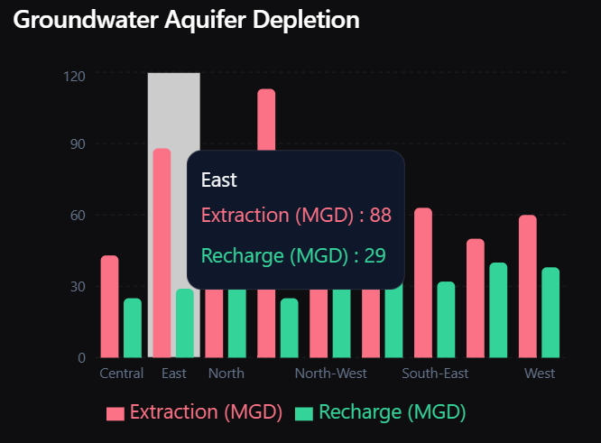
Fig 1 - Groundwater Aquifer Depletion Analysis showing water being pulled Vs replenished.

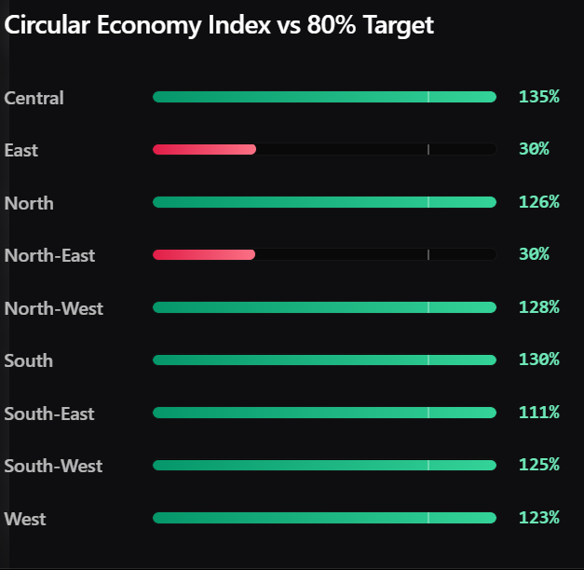
Fig 2 – Waste Generated Vs Recycled

4.2 Methodological Alignment & Theoretical Framework

The design of the InfraVision platform is grounded in a hybrid theoretical framework that combines time-series econometrics with advanced machine learning ensembles. Unlike traditional urban planning research that often relies on linear regression, this project aligns its methodology with the non-linear complexities of city growth. By utilizing the Prophet forecasting architecture, the system incorporates a piecewise linear growth model that accounts for the "saturation points" of urban infrastructure. This alignment is critical because city resources do not grow indefinitely; they are limited by physical and geographic constraints. By referencing existing research on urban metabolism, InfraVision justifies the use of additive modelling to decompose city telemetry into trend, seasonality, and holiday effects, ensuring that the predictive outputs are scientifically sound and contextually aware.
Furthermore, the integration of XGBoost (Extreme Gradient Boosting) within this framework addresses the limitations of previous decision-tree models by implementing a gradient-descent based optimization that is highly resilient to data noise. The methodological choice to include SHAP (Shapley Additive Explanations) as a core component is a direct response to the "interpretability gap" identified in modern smart city literature. By aligning the project with the principles of Coalitional Game Theory, the system ensures that every infrastructure optimization score is mathematically fair and transparent. This theoretical alignment provides a robust foundation for the platform's optimization algorithms, ensuring that the transition from raw municipal data to "Next-Gen" infrastructure recommendations is both logically consistent and technically superior to existing deterministic solutions.
- Methodology

5.1 Introduction to Languages and Frameworks (Frontend & Backend)

The development of the InfraVision platform necessitated a robust, dual-stack architecture to balance high-fidelity user interaction with intensive computational AI processing. The Frontend is engineered using TypeScript within the Next.js 14 ecosystem. TypeScript was selected as the primary language to ensure type-safety and maintainability across a complex codebase involving thousands of reactive components. By leveraging Next.js 14, the platform utilizes Server-Side Rendering (SSR) and Optimized Client-Side Hydration, which significantly reduces the Initial Page Load time—a critical requirement for a data-heavy dashboard. The visual layer is further enhanced by Tailwind CSS for ultra-responsive design and Framer Motion for implementing micro-animations, ensuring that the interface feels fluid and state-of-the-art.
On the Backend, the platform employs a specialized dual-engine approach. For handling user authentication, session management, and database orchestration, the system utilizes Node.js integrated with the Prisma ORM. This provides a seamless, type-safe connection to the PostgreSQL database, ensuring high data integrity. However, for the core "Intelligence" layer, the project transitions to a Python-based FastAPI architecture. Python was the definitive choice for the AI backend due to its unparalleled ecosystem of scientific libraries such as Pandas, scikit-learn, and Prophet. FastAPI provides the high-performance, asynchronous capabilities required to serve ML predictions and Digital Twin simulations in real-time. This combination of Node.js for structural integrity and Python for scientific computation ensures that InfraVision can scale while remaining computationally efficient.
The communication between these two layers is handled via a RESTful API architecture, where the Next.js frontend acts as a proxy to the Python AI engine. To handle real-time infrastructure alerts, the system implements SSE (Server-Sent Events), allowing the backend to push critical notifications to the user without the overhead of constant polling. By strategically choosing this language mix, the platform achieves a perfect synergy between modern web standards and institutional-grade artificial intelligence.

Table 1 – InfraVision Technology Stack Summary

Layer | Technology / Language | Primary Role in Project
Frontend | Next.js 14 (TypeScript) | Reactive UI, Server-Side Rendering, and Client-Side Logic
Styling | Tailwind CSS | Utility-first design and responsive layout management.
Backend (Core) | Node.js / Next.js API | Authentication, Database Proxy, and Session Management
AI Backend | Python (FastAPI) | ML Inference, Prophet Forecasting, and SHAP Computations.
Database | PostgreSQL & SQLite | Persistent storage for users, metadata, and city telemetry.
ORM | Prisma & SQLAlchemy | Type-safe database mapping and complex query orchestration.
Visualization | Recharts & Mapbox GL JS | Dynamic data charting and high-fidelity 3D city mapping.
Animation | Framer Motion | Implementation of smooth micro-interactions and transitions.

5.2 Supporting Libraries and specialised Packages
Beyond the core programming languages, the InfraVision ecosystem relies on a curated selection of supporting libraries that enable specialized functionalities. In the AI backend, Pandas and NumPy are utilized extensively for high-performance data manipulation and numerical vectorization, ensuring that large-scale municipal datasets are processed with minimal latency. For the predictive modelling layer, the system leverages XGBoost for its robust gradient-boosting capabilities and Meta’s Prophet library for sophisticated time-series forecasting. The transparency of these models is maintained through the SHAP (SHapley Additive exPlanations) package, which allows the system to compute localized feature importance. Additionally, the PuLP library is integrated to handle the project’s resource optimization tasks, utilizing Linear Programming (LP) to solve for the most efficient allocation of infrastructure budgets.
On the web-service and communication layer, the platform utilizes Pydantic for rigorous data validation and schema enforcement, ensuring that all information exchanged between the frontend and backend is accurate and structured. Asynchronous HTTP requests are managed via httpx, while sse-starlette is employed to maintain the Server-Sent Events stream for real-time system alerts. For database operations, SQLAlchemy and aiosqlite provide a high-level abstraction for the Python backend, allowing for non-blocking database queries.
The frontend experience is further augmented by several specialized React-based packages. Lucide-React provides the iconographic system used for navigation and status indicators, while Radix UI primitives are used to build accessible, high-quality interface components such as modals and dropdowns. Data parsing on the client-side, specifically for handling user-uploaded infrastructure reports, is facilitated by PapaParse and XLSX, which allow the system to process CSV and Excel files directly within the browser. Finally, Sonner is utilized for providing real-time, non-intrusive toast notifications, ensuring that users receive immediate feedback on system operations and AI inference statuses. This extensive array of supporting packages ensures that every layer of InfraVision is powered by industry-standard, high-performance tools.
Table 2 – Specialized Supporting Libraries and Packages

Category | Package/Library | Technical Function
Machine Learning | XGBoost & Prophet | Advanced gradient boosting and multi-seasonal time-series forecasting.
Explainable AI | SHAP | Mathematical decomposition of ML models for decision transparency.
Optimization | PuLP | Solving Linear Programming (LP) problems for resource allocation.
Data Processing | Pandas & NumPy | High-speed data cleaning, transformation, and vector arithmetic.
Validation | Pydantic | Data structure enforcement and automated schema validation.
Networking | FastAPI & Httpx | Asynchronous API routing and high-performance server communication.
Real-Time comms | SSE – Starlette | Implementation of Seerver-sent events for live infrastructure alerts
File Parsing | PapaParse & XLSX | Client-side parsing of CSV and Excel-based infrastructure reports
UI Components | Radix UI & Lucide | Accessible interface primitives and high-fidelity vector iconography.
Database ORM | Prisma & SQL Alchemy | Abstraction layers for PostgreSQL and SQLite data management.

5.3 User Characteristics
The InfraVision platform is engineered to serve a diverse spectrum of users within the urban planning and infrastructure management ecosystem, ranging from executive decision-makers to technical researchers. The primary users are Urban Administrators and Policy Makers, who require high-level, automated optimization strategies to streamline city-wide resource allocation. For these users, the system acts as a strategic command center, reducing the manual effort involved in report synthesis and providing clear, AI-driven recommendations that improve the efficiency of municipal governance.
In addition to executive leadership, the system is designed for City Planners and Infrastructure Engineers. These users leverage the platform’s advanced analytical capabilities to assess systemic risks, analyze the projected impact of new developments, and evaluate the confidence levels associated with different infrastructure trajectories. By utilizing the Digital Twin and stress-testing modules, they can observe how various policy interventions will perform under environmental pressure, enabling a more proactive approach to urban resilience.
Finally, the platform caters to Environmental Researchers and Academic Learners, providing an interactive environment for exploring urban sustainability trends. These users can experiment with different environmental assumptions—such as shifts in renewable energy targets or population growth rates—and observe their direct impact on city-wide sustainability scores. The interface is intentionally designed to be intuitive, ensuring that even individuals with limited technical expertise in data science can navigate complex urban telemetry while still accessing institutional-grade analytical tools.

4.4 Constraints
The implementation of the system is subject to several constraints that influence its performance and usability:

Table 4: Constraints in the System

Constraint | Type | Impact
Computational Overhead | Technical | Intensive AI operations (Prophet & SHAP) may increase inference latency during complex simulations.
Municipal Data Quality | Operational | The accuracy of optimization outputs is highly dependent on the integrity and consistency of raw government datasets.
Storage & Memory Limits | System | Large-scale 3D city maps and extensive GeoJSON spatial data require significant local cache and memory resources.
Model Determinism | Analytical | Future growth forecasts are based on historical trajectories and may not account for sudden, extreme socio-economic shifts.
Geographic Scope | Operational | The current system architecture is optimized for the Delhi-NCR region and requires recalibration for other urban contexts.

5.5 System Flow and Data Flow
A. System Flow
The system follows a structured pipeline that transforms user input into actionable insights:
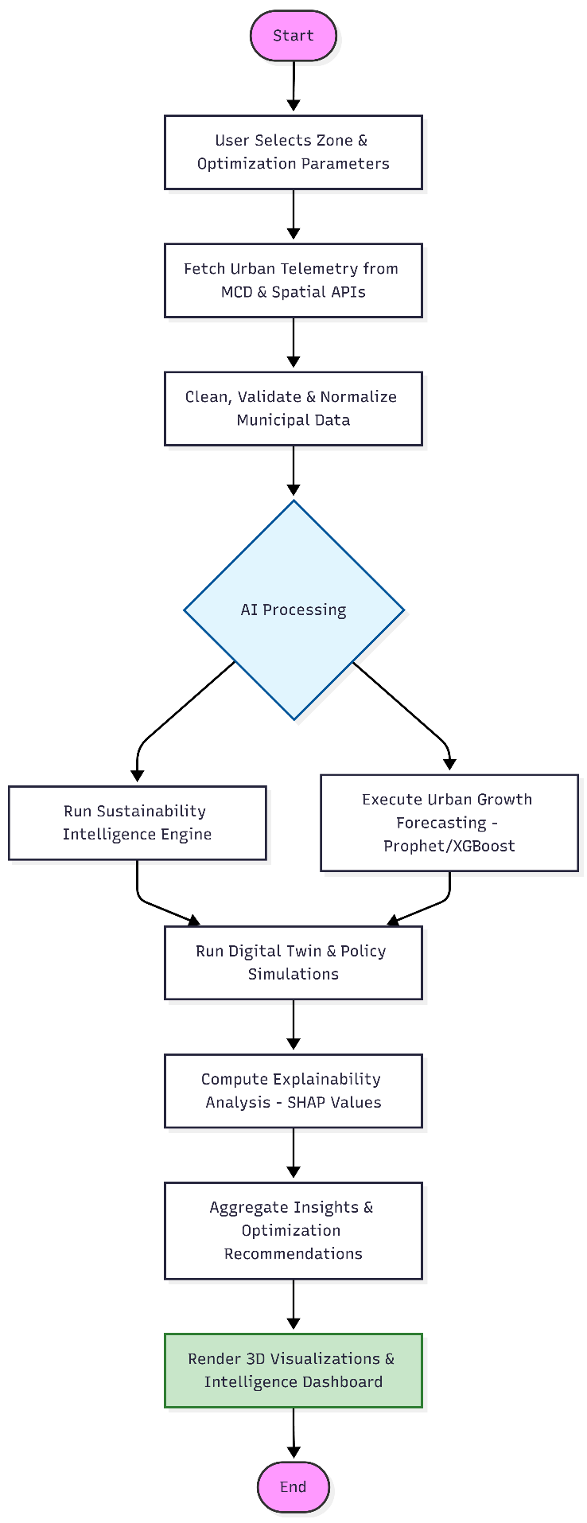
Fig 4 – System flow of InfraVision

B. Data Flow
The system processes data through a continuous interaction between the user, system, and external data sources:
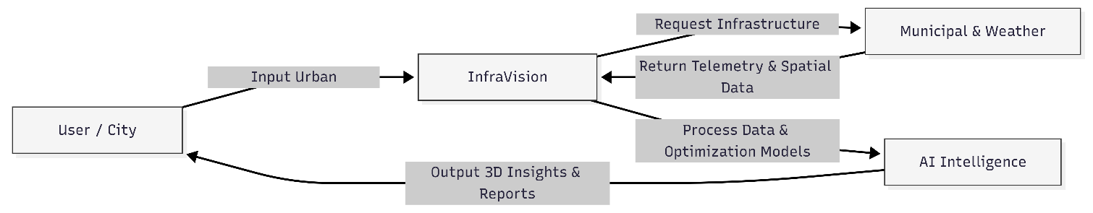
Fig 5 - System Data Flow Process

5.6 Database Design
The InfraVision platform utilizes a sophisticated dual-database architecture designed to balance the requirements of high-fidelity web management with intensive machine learning inference. The primary relational database is powered by PostgreSQL, orchestrated through the Prisma ORM. This database serves as the system's "Administrative Layer," managing user authentication, session persistence, and localized project metadata. By utilizing PostgreSQL, the platform ensures ACID compliance and high data integrity for critical operations like saved policy scenarios and customized user configurations. The schema is designed following the Third Normal Form (3NF) to ensure scalability and eliminate data redundancy, with specialized indexes placed on geographic identifiers and temporal markers to minimize query execution times.
Complementing the primary database is a localized SQLite engine (sustainability.db), specifically optimized for the Python-based AI core. This "Intelligence Layer" database stores the vast repositories of historical municipal telemetry, ranging from hourly water extraction rates to annual carbon footprints. SQLite was chosen for this role due to its high-speed, file-based access, which allows the Prophet and XGBoost models to perform rapid feature extraction without the network overhead associated with traditional client-server databases. This dual-architecture strategy ensures that while the frontend remains highly responsive, the backend AI engines have dedicated, low-latency access to the historical datasets required for real-time urban optimization.
The database schema is centered around a Zone-Temporal Matrix, where the Zone and Year serve as the primary composite keys for most resource tables. This structure allows the system to perform complex aggregations and cross-sectional analyses—such as comparing the "Sustainability Score" of the North-West zone against the city average—with extreme efficiency. Furthermore, the system implements a "High-Signal" caching layer within the database design, where frequently accessed AI predictions and SHAP explainability scores are pre-computed and stored. This reduces the need for redundant ML inference cycles and ensures that the platform provides a seamless, high-performance experience for urban administrators.

5.7 Table Structure
The following tables represent the core relational schema of the InfraVision platform, showcasing how municipal telemetry and AI outputs are structured for high-performance retrieval.
Table 5 – Zones (Geographical Metadata)

Column Name | Data Type | Description
id | UUID (PK) | Unique identifier for each geographic sector.
Name | String | Common name of the zone (e.g., "North-West", "Central").
Pincode | Integer | Primary postal code for the zone.
Geo_json | JSONB | Spatial coordinates for rendering 3D Mapbox boundaries.
Sq_km | Float | Total area of the zone in square kilometers.

Table 6 – Sustainability_Metrics (Historical Telemetry)

Column Name | Data Type | Description
id | BigInt (PK) | Unique record ID.
Zone_id | UUID (PK) | Reference to the zones table.
Year | Integer | The fiscal year of the data record.
Water_Supply | Float | Total water supply in MGD (Million Gallons per Day).
Energy_mu | Float | Total energy consumption in Million Units (MU).
Ghg_mtco2 | Float | Total Greenhouse Gas emissions in MtCO2.
Sustainability_Score | Float | The calculated base sustainability index for that year.

5.8 Entity Relationship Overview
The logical structure of the system defines relationships between financial entities:
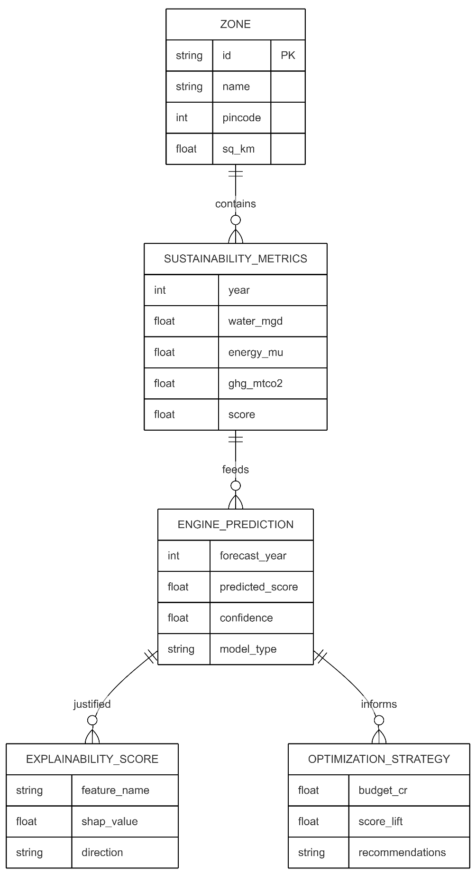
Fig 5 - ER Diagram of the system

5.9 Assumptions and Dependencies
Assumptions - The statistical validity of the InfraVision platform is grounded in several core assumptions regarding the dynamics of the urban environment. Primarily, the system assumes that city growth and infrastructure demand follow non-linear trajectories, which are accurately captured through the piecewise linear modeling of the Prophet forecasting engine. It is further assumed that a strong mathematical correlation exists between localized population density and utility consumption rates, allowing demographic shifts to act as a primary driver for stress-testing simulations. Additionally, the project operates under the assumption that institutional sustainability targets, such as the 80% waste-processing benchmark, remain fixed goals for the purpose of measuring optimization success. Finally, the forecasting logic assumes structural continuity in municipal management, where historical trends are expected to persist unless they are explicitly modified by simulated policy interventions.
Dependencies - The operational success of the platform relies on several critical external dependencies that influence both data accuracy and system performance. The primary dependency is the integrity of municipal datasets provided by the Municipal Corporation of Delhi (MCD), as the quality of AI-driven insights is directly proportional to the reliability of this raw telemetry. For spatial visualization, the system is dependent on the Mapbox GL JS engine and its real-time vector tile services to render detailed 3D geographic boundaries. Furthermore, the system’s analytical depth is tied to the stability and version-consistency of the underlying Python scientific libraries, specifically the Prophet, XGBoost, and SHAP frameworks. Lastly, a consistent internet connection is a vital physical dependency, required for the retrieval of real-time weather data and the fluid rendering of all cloud-hosted map components.

5.10 Algorithm Discussion
The intelligence core of the InfraVision platform is built upon a hybrid ensemble of machine learning and optimization algorithms, each selected for its specific strength in urban analytics. For time-series forecasting, the system utilizes Meta’s Prophet algorithm. Prophet was chosen for its ability to model urban growth as a piecewise linear trend, effectively handling the multi-seasonal nature of city data—such as weekly traffic cycles or annual utility surges—while remaining robust to the missing data points often found in municipal records. Complementing this is the XGBoost (Extreme Gradient Boosting) regressor, which serves as the primary engine for cross-sectional risk prediction. XGBoost’s gradient-descent framework is utilized to capture complex, non-linear interactions between diverse features like population density, energy intensity, and water stress, providing the system with high predictive accuracy.
To ensure that these "black box" machine learning models are transparent and accountable, the platform implements the SHAP (SHapley Additive exPlanations) algorithm. Rooted in coalitional game theory, SHAP mathematically decomposes each optimization score into the individual contributions of its underlying features. This allows urban planners to see exactly how much each variable (e.g., a 5% increase in renewable energy) shifted the final prediction. Finally, the system employs Linear Programming (LP) optimization via the PuLP library. This algorithm is used to solve the "Resource Allocation Problem," where the system calculates the most efficient distribution of a limited municipal budget across various infrastructure projects to maximize the overall sustainability lift while adhering to strict environmental and financial constraints.

  - Implementation of Algorithm with Screenshots & Figures
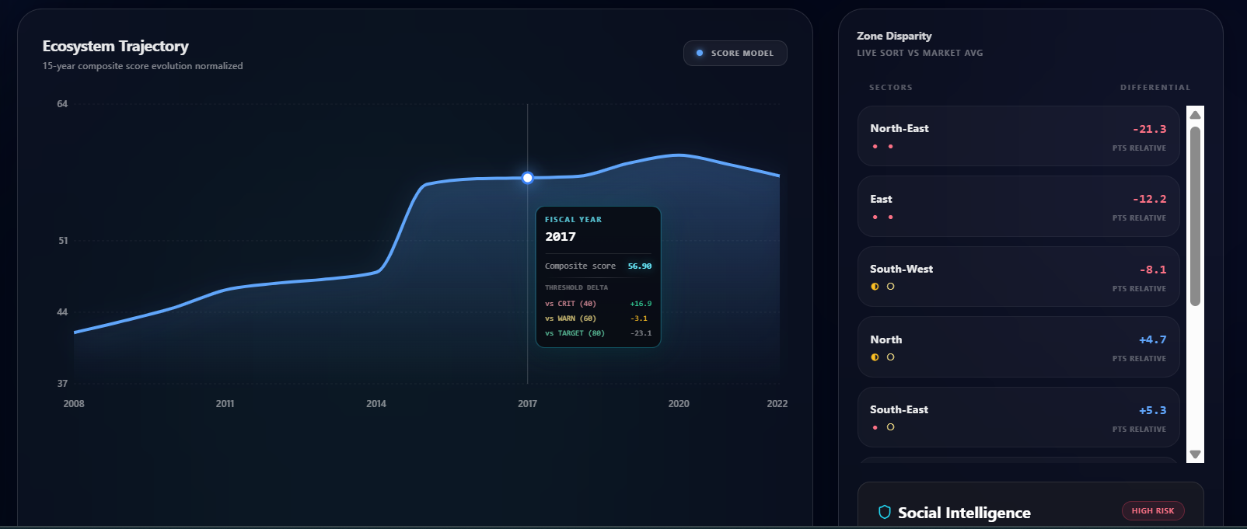
Fig 6 - demonstrates the execution of the Prophet forecasting engine. The system projects a 15-year evolution of the urban ecosystem, visualizing the confidence intervals and trend shifts detected by the algorithm.

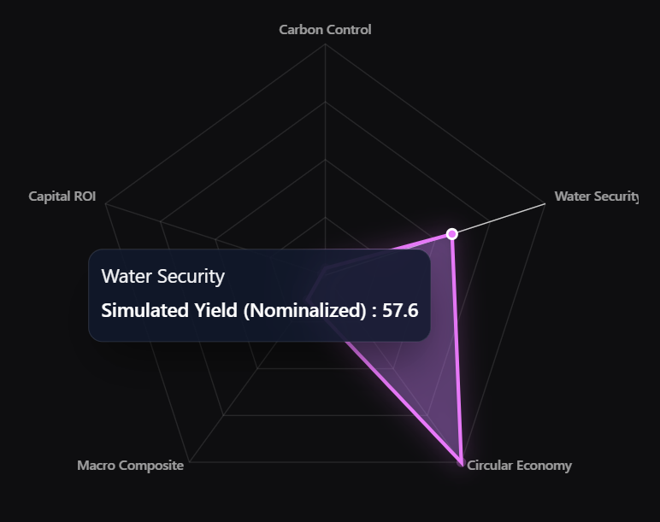
Fig 7 - This visualization represents the final output of the Linear Programming optimization layer. The Impact Radar Topology shows how the system has balanced a limited budget across multiple vectors such as Water Security and Carbon Control to achieve an optimal infrastructutr.

- RESULTS
The results obtained from the InfraVision system's data extraction and spatial analysis modules are presented below. The system utilizes OpenStreetMap data via Overpass Turbo to map critical urban infrastructure including hospitals, schools, and parks across major zones like Delhi and Manesar.

Figure 1: Hospital Infrastructure Mapping in Delhi
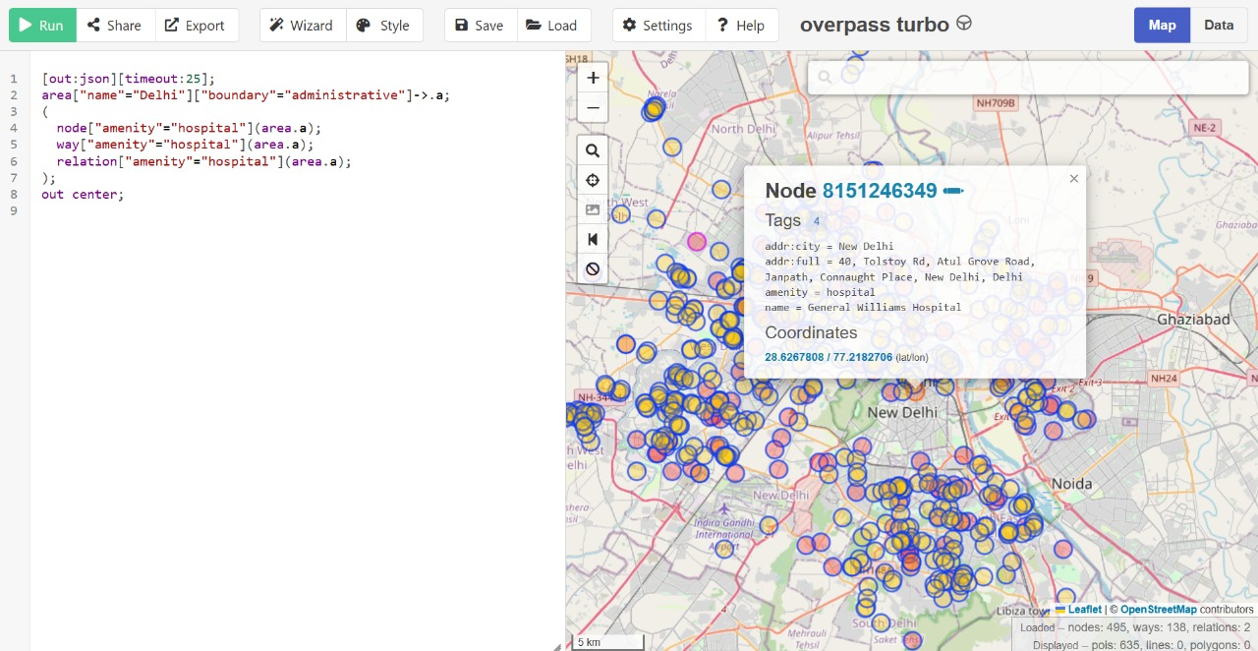
This visualization shows the density and distribution of hospitals in Delhi, extracted using the 'amenity=hospital' query. The concentration of healthcare facilities is higher in central and southern zones.

Figure 2: Public Park and Green Space Distribution in Delhi
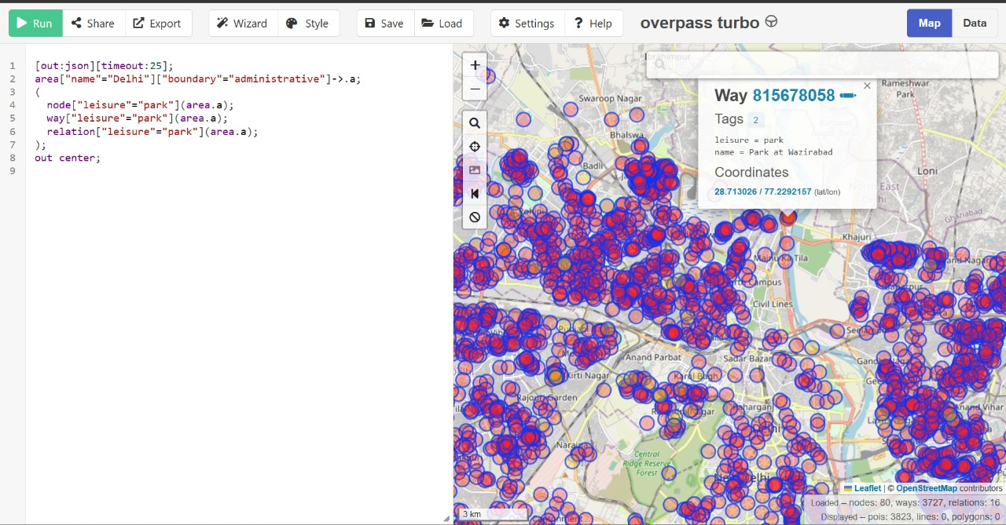
The mapping of leisure spaces (parks) indicates a widespread distribution across the city, providing essential green cover data for sustainability analysis.

Figure 3: Educational Infrastructure (Schools) in Delhi
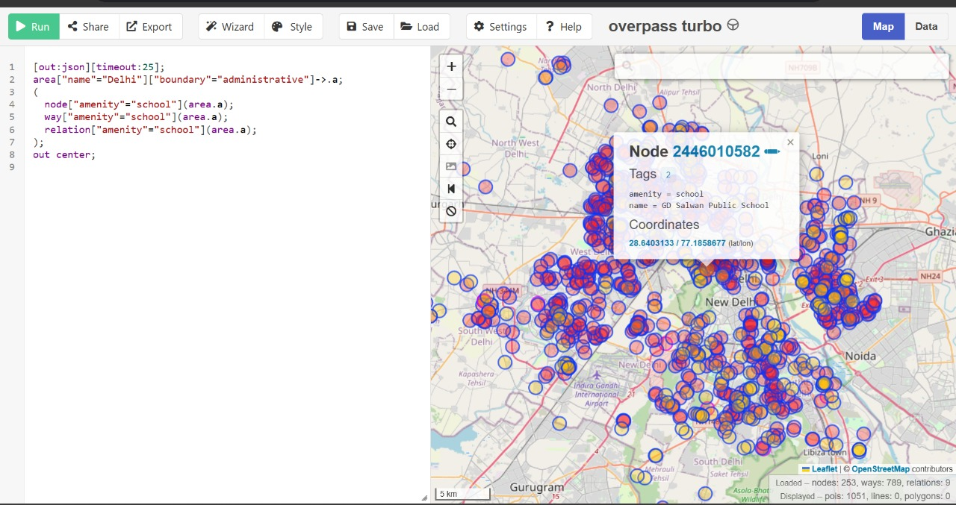
Educational institutions are mapped to evaluate school coverage and accessibility for the urban population.

Figure 4: Integrated Infrastructure Analysis for Manesar Zone
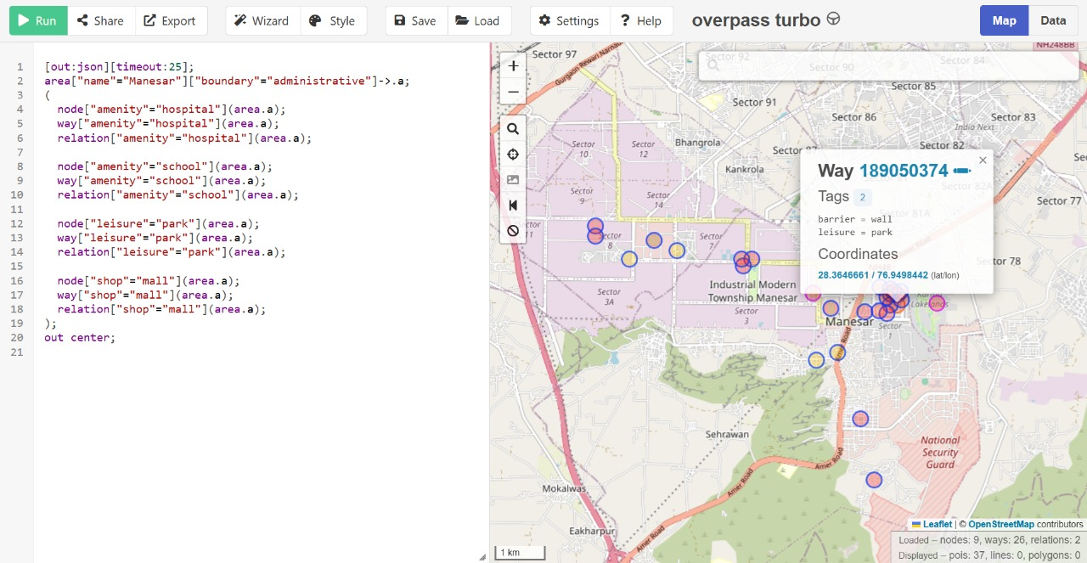
A multi-layered analysis of Manesar showing the intersection of hospitals, schools, parks, and shopping malls, highlighting the system's ability to handle diverse urban zones.

CHAPTER-6
CONCLUSION AND FUTURE SCOPE

6.1 Conclusion
The proposed Financial Modelling Software successfully overcomes the limitations of traditional financial modelling techniques by providing an integrated, automated, and dynamic platform for asset valuation. Unlike conventional spreadsheet-based approaches, the system combines multiple financial models, real-time data integration, and advanced analytical methods to deliver more accurate and insightful results.
By incorporating Discounted Cash Flow (DCF) and Leveraged Buyout (LBO) models, the system provides a comprehensive evaluation of asset value from both intrinsic and returns-based perspectives. The integration of Monte Carlo simulation enables the system to capture uncertainty and generate a range of possible outcomes, thereby improving risk assessment. Additionally, the inclusion of the Linear Ballistic Accumulator (LBA) model enhances decision-making by providing a confidence-based interpretation of results.
The system demonstrates high computational efficiency, user-friendly interaction, and the ability to transform complex financial data into meaningful insights. Overall, the project achieves its objective of developing a robust, scalable, and practical financial modelling tool that supports informed decision-making in modern financial environments.

6.2 Future Scope
Although the system performs effectively, several enhancements can be implemented to further improve its capabilities:
- Integration of Additional Valuation Models:
Future versions can include models such as Comparable Company Analysis (CCA) and Precedent Transactions to broaden the analytical scope.
- Advanced Risk Analysis Techniques:
More sophisticated methods like stress testing and macroeconomic scenario modelling can be incorporated to enhance risk evaluation.
- Database Integration:
The system can be extended to include persistent storage for saving user sessions, historical data, and analysis results.
- Real-Time Alerts and Notifications:
Features such as automated alerts for valuation changes or risk thresholds can be added for proactive decision-making.
- Enhanced Visualization and Reporting:
Additional visualization tools and exportable reports can be implemented to improve usability and presentation.
CHAPTER-7
BIBLOGRAPHY

[1] T. Copeland, T. Koller, and J. Murrin, Valuation: Measuring and Managing the Value of Companies, 5th ed., Wiley, 2010.
[2] A. Damodaran, Investment Valuation: Tools and Techniques for Determining the Value of Any Asset, 3rd ed., Wiley, 2012.
[3] S. Ross, R. Westerfield, and J. Jaffe, Corporate Finance, 10th ed., McGraw-Hill, 2013.
[4] P. Glasserman, Monte Carlo Methods in Financial Engineering, Springer, 2004.
[5] J. Hull, Options, Futures, and Other Derivatives, 9th ed., Pearson, 2014.
[6] M. L. Puterman, Markov Decision Processes: Discrete Stochastic Dynamic Programming, Wiley, 1994.
[7] A. Tversky and D. Kahneman, “Judgment under Uncertainty: Heuristics and Biases,” Science, vol. 185, no. 4157, pp. 1124–1131, 1974.
[8] R. Ratcliff and G. McKoon, “The Diffusion Decision Model: Theory and Data for Two-Choice Decision Tasks,” Neural Computation, vol. 20, no. 4, pp. 873–922, 2008.
[9] Yahoo Finance, “Financial Data API,” Available: https://finance.yahoo.com/
[10] Financial Modeling Prep, “FMP Cloud API Documentation,” Available: https://financialmodelingprep.com/developer/docs/
[11] W. McKinney, “Data Structures for Statistical Computing in Python,” Proceedings of the 9th Python in Science Conference, 2010.
[12] T. Oliphant, Guide to NumPy, USA: Trelgol Publishing, 2006.
[13] Plotly Technologies Inc., “Plotly: Interactive Data Visualization Library,” Available: https://plotly.com/
[14] Streamlit Inc., “Streamlit Documentation,” Available: https://streamlit.io/

